# **Diagnosing bias and variance**

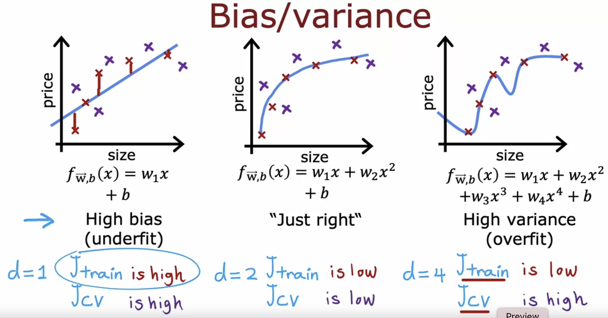

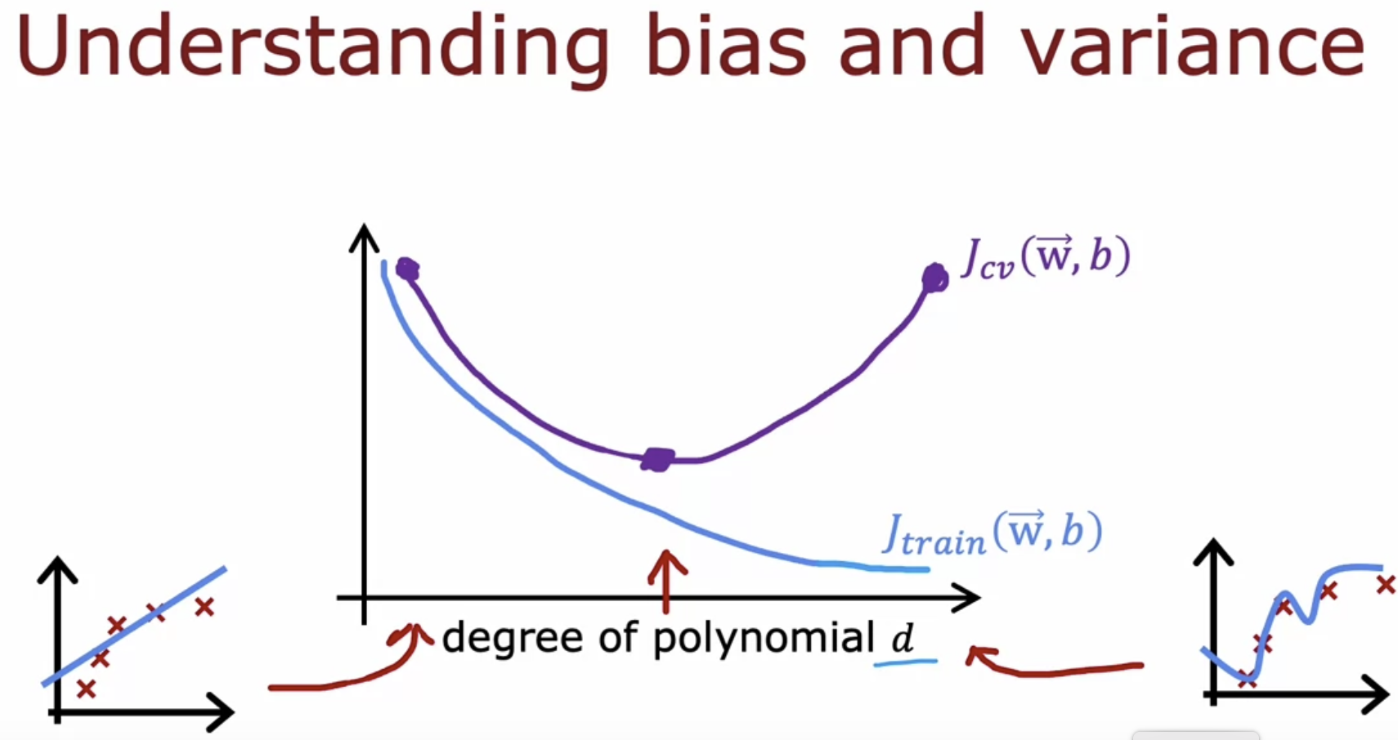

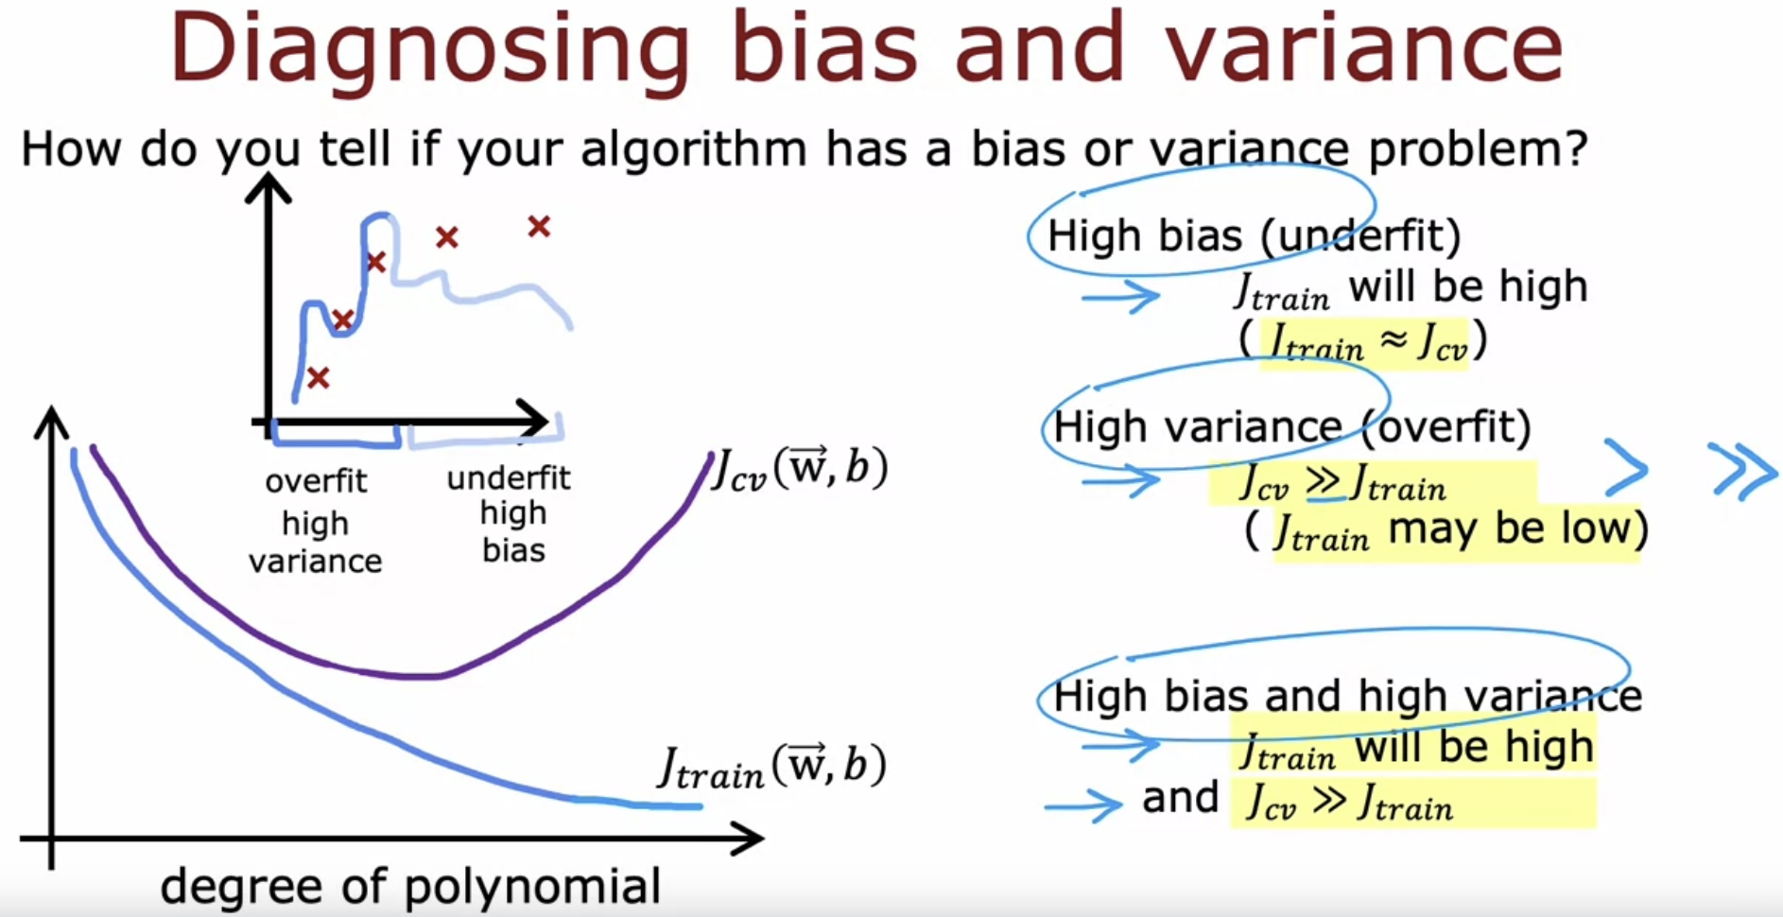

High bias 🡪 the algorithm does poorly on the training set  
High variance 🡪 the algorithm does poorly on the training set and validation set

# **Regularization and bias/variance**

Aim : Fitting a 4th order polynomial (i.e the model) + regularization. How to choose lambda ?

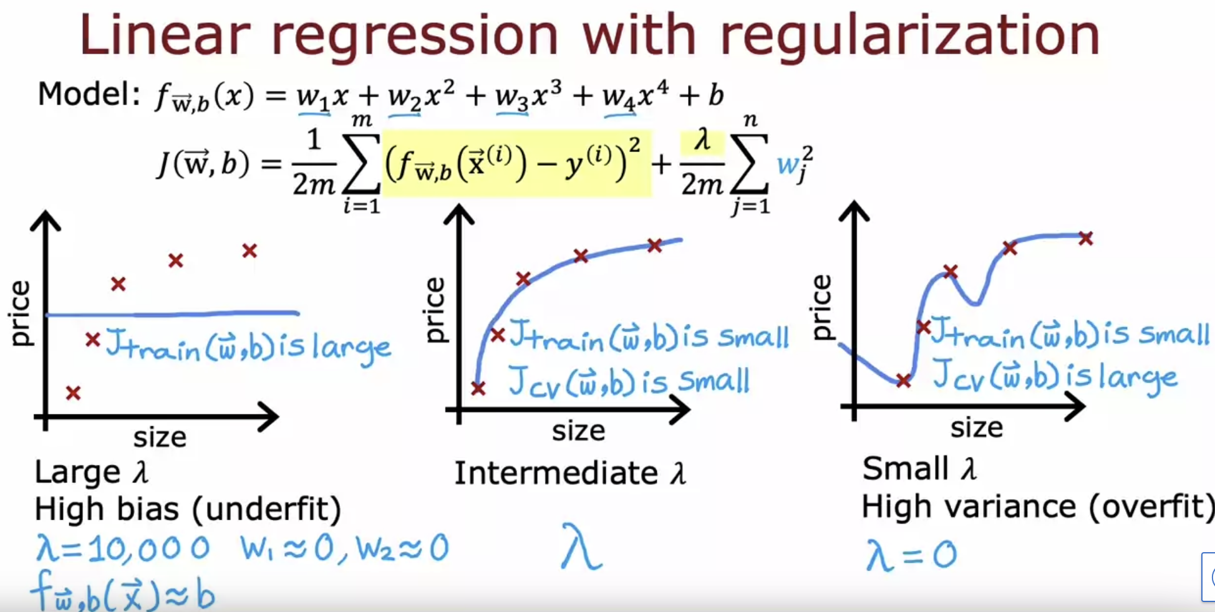

If lambda is very large, then the algorithm is highly   
motivated to keep these parameters w very small.

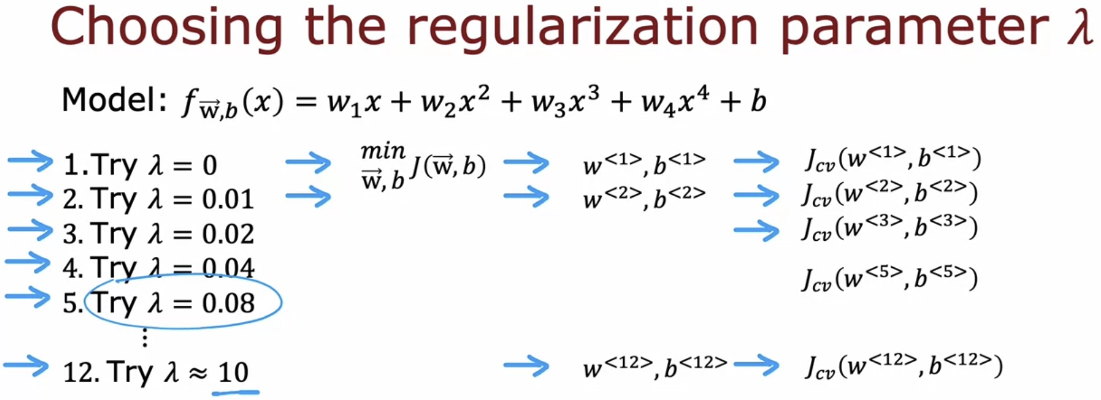

Here lambda = 0.08 performs well on the validation data-set.



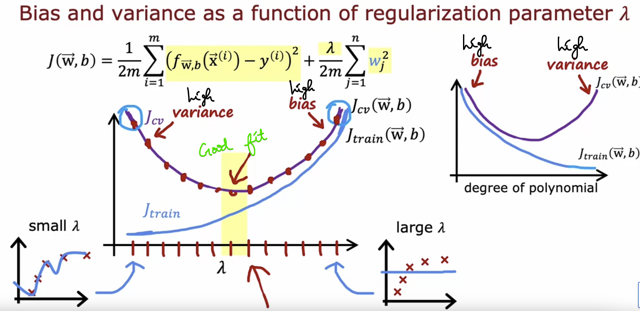

# **Establishing a baseline level of performance**

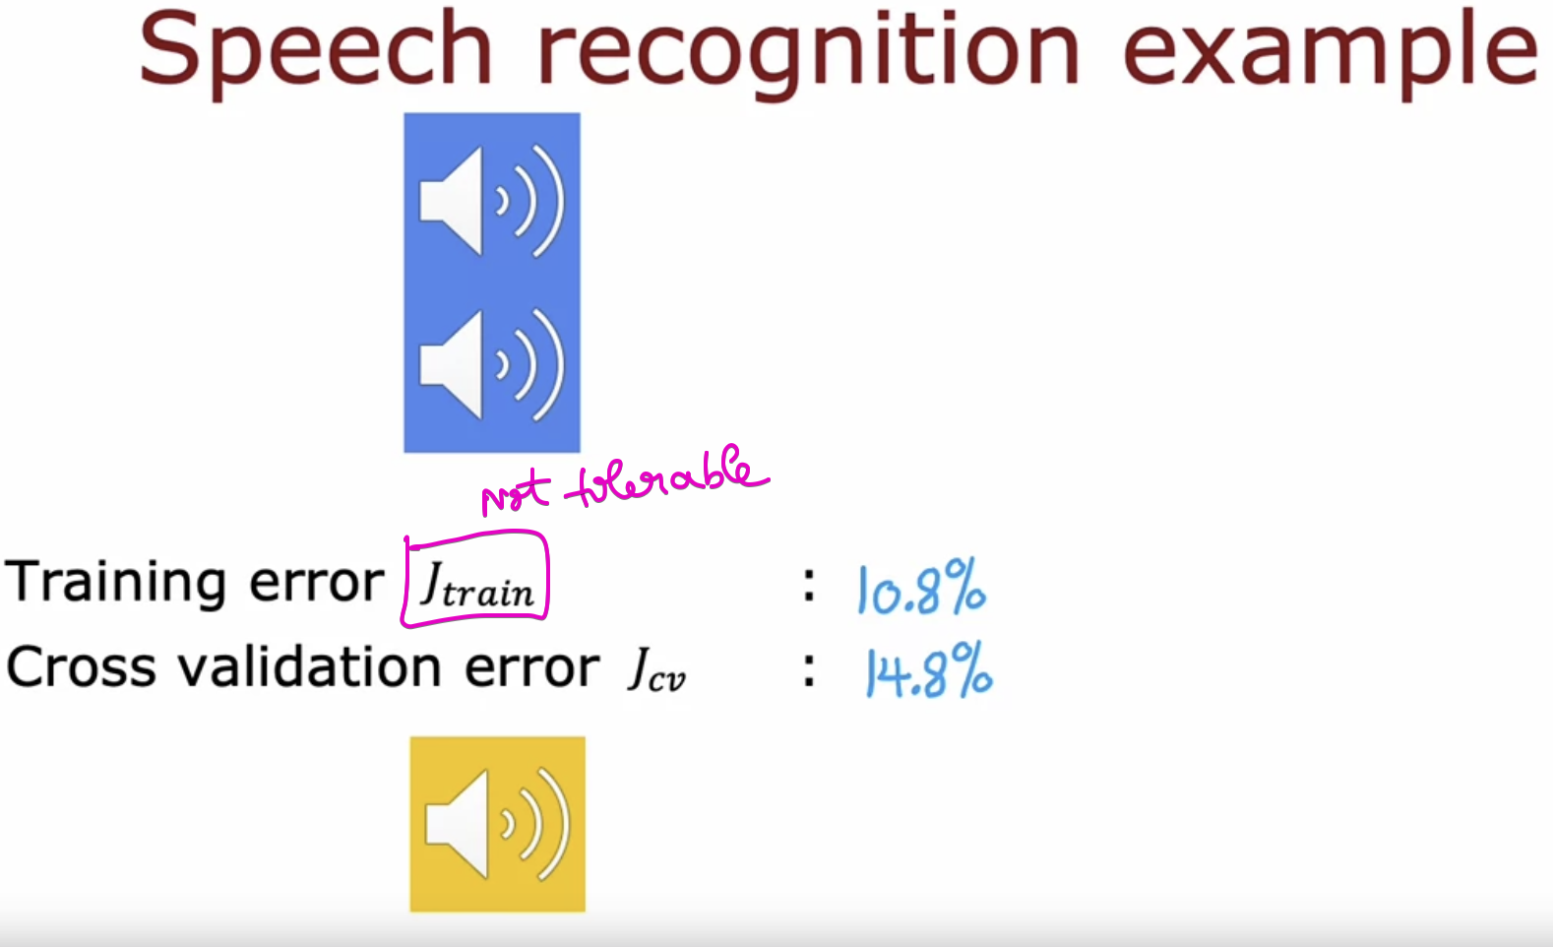

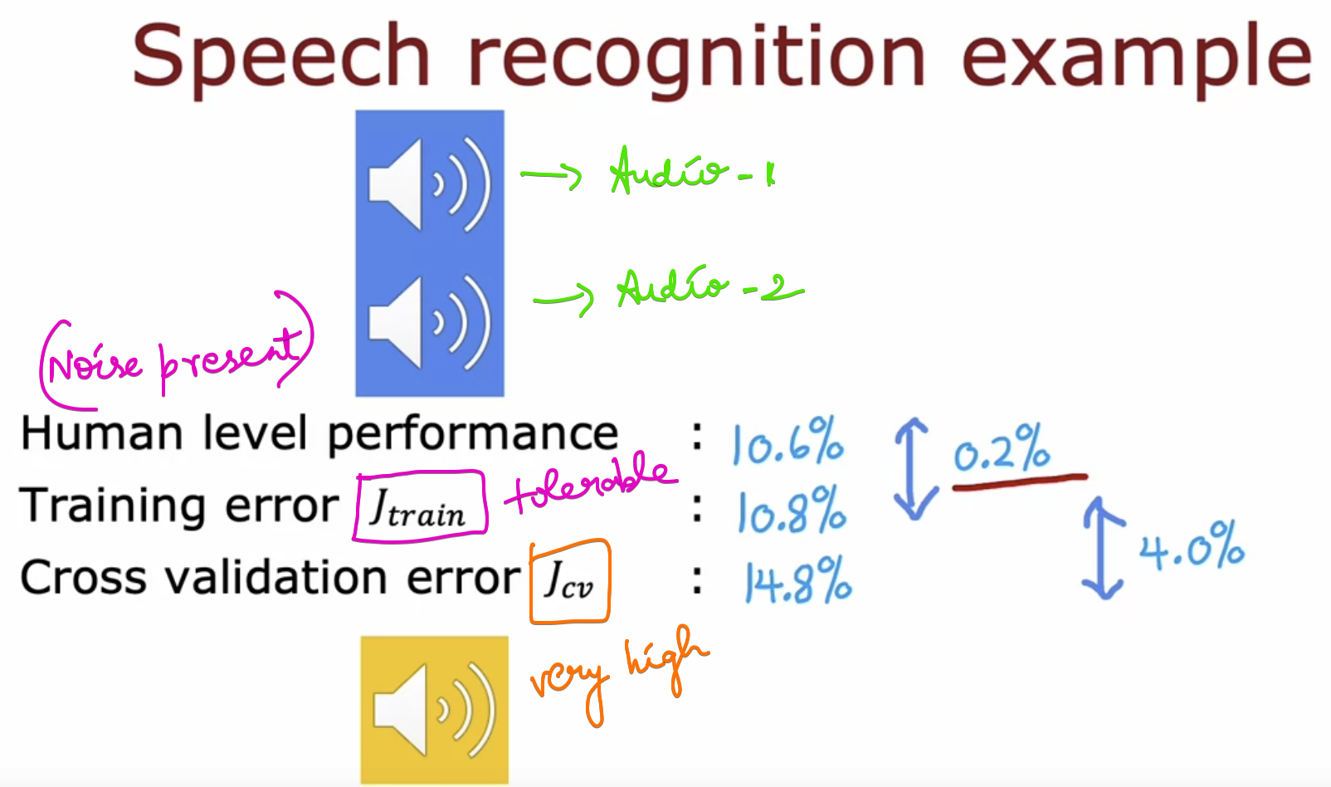

This algorithm has more variance problem than bias problem.

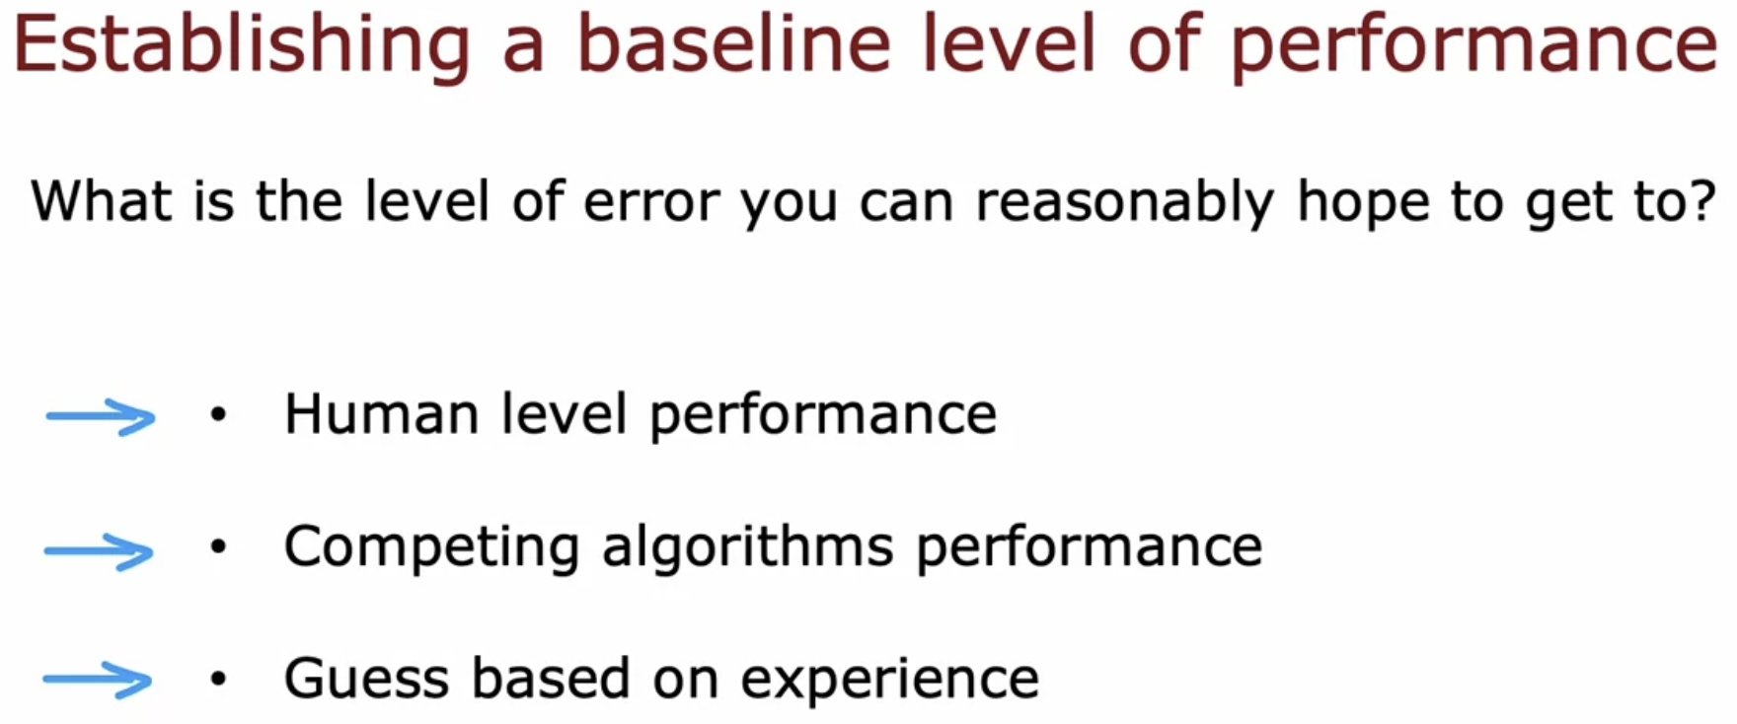

## **What does “baseline” means in the context of ML ???**

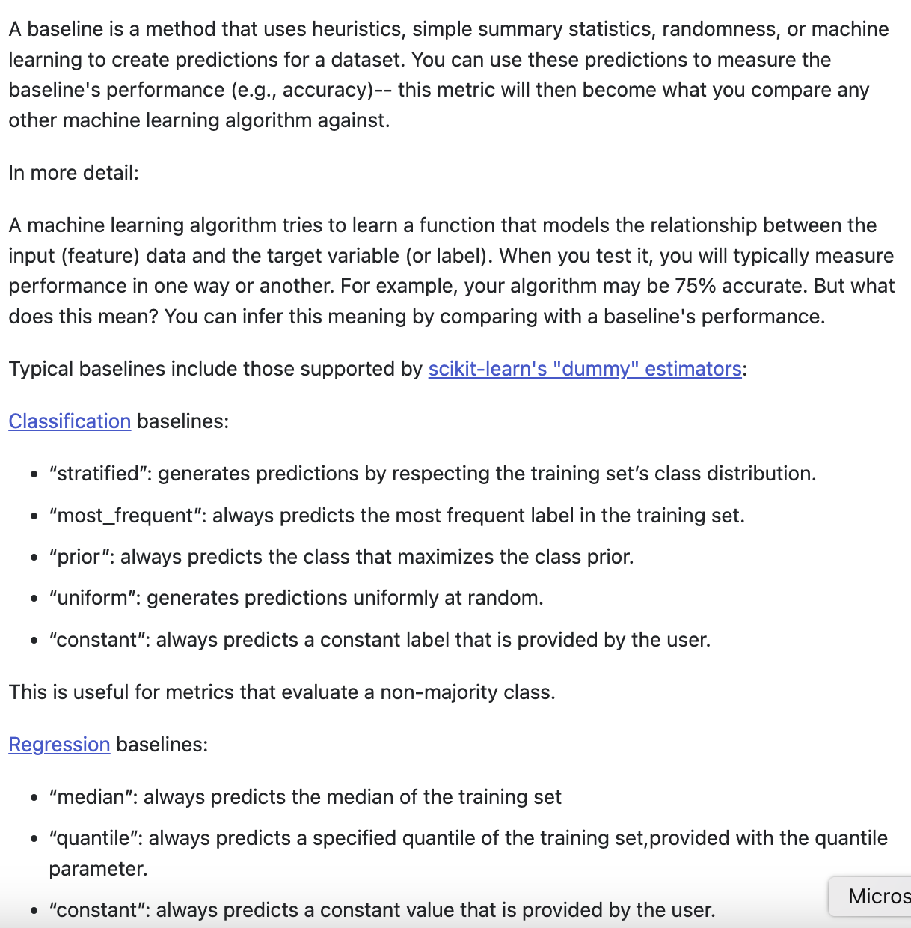  
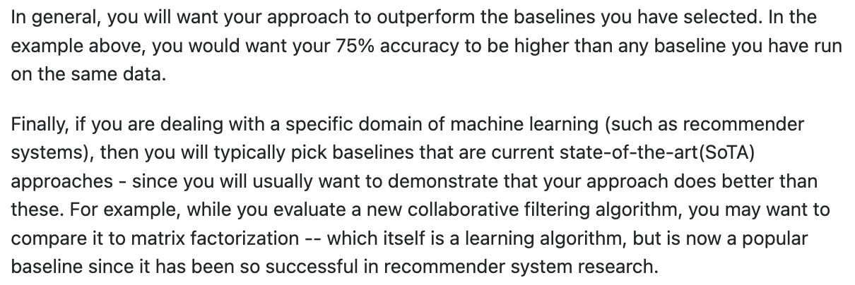

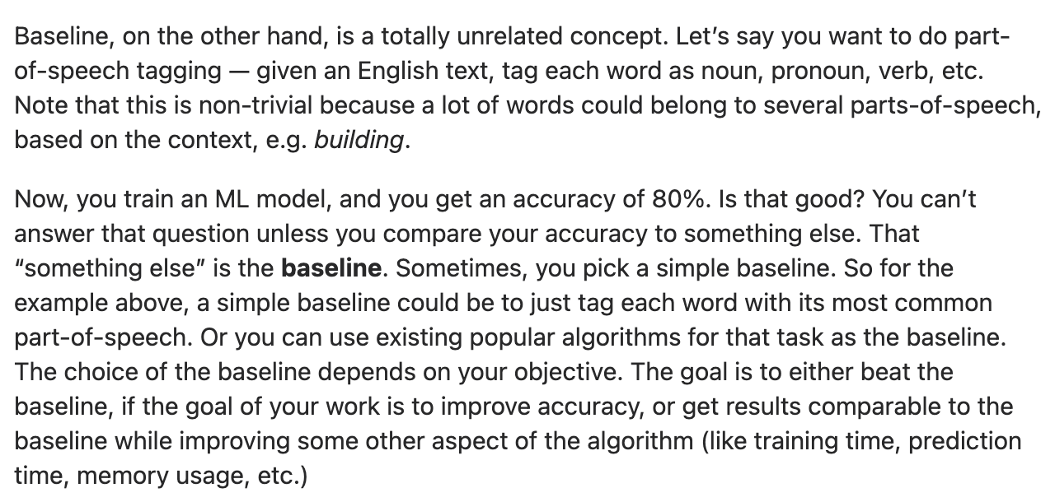

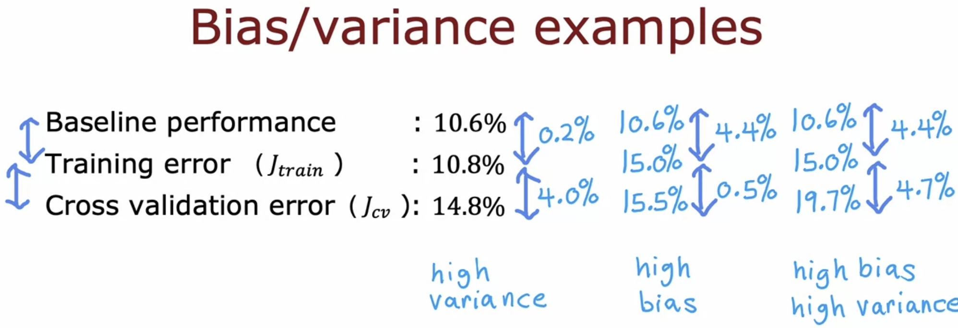

# **Learning curves**

Learning curves are a way to help understand how your learning algorithm is doing as a function of the amount of experience it has, whereby experience, I mean, for example, the number of training examples it has.

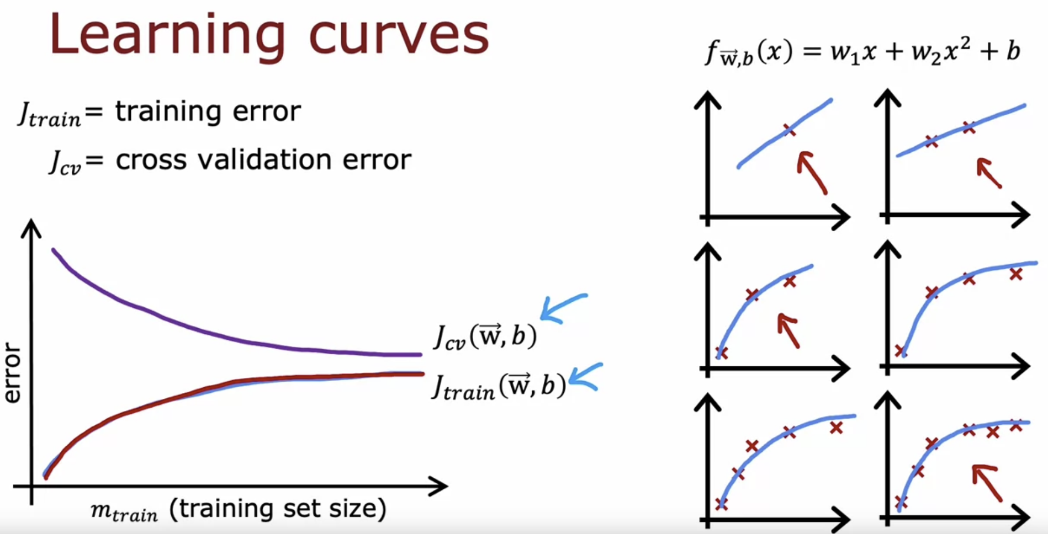

As the training data increases, training error also increases.

## **High Bias Problem 🡪 Underfitting Problem**

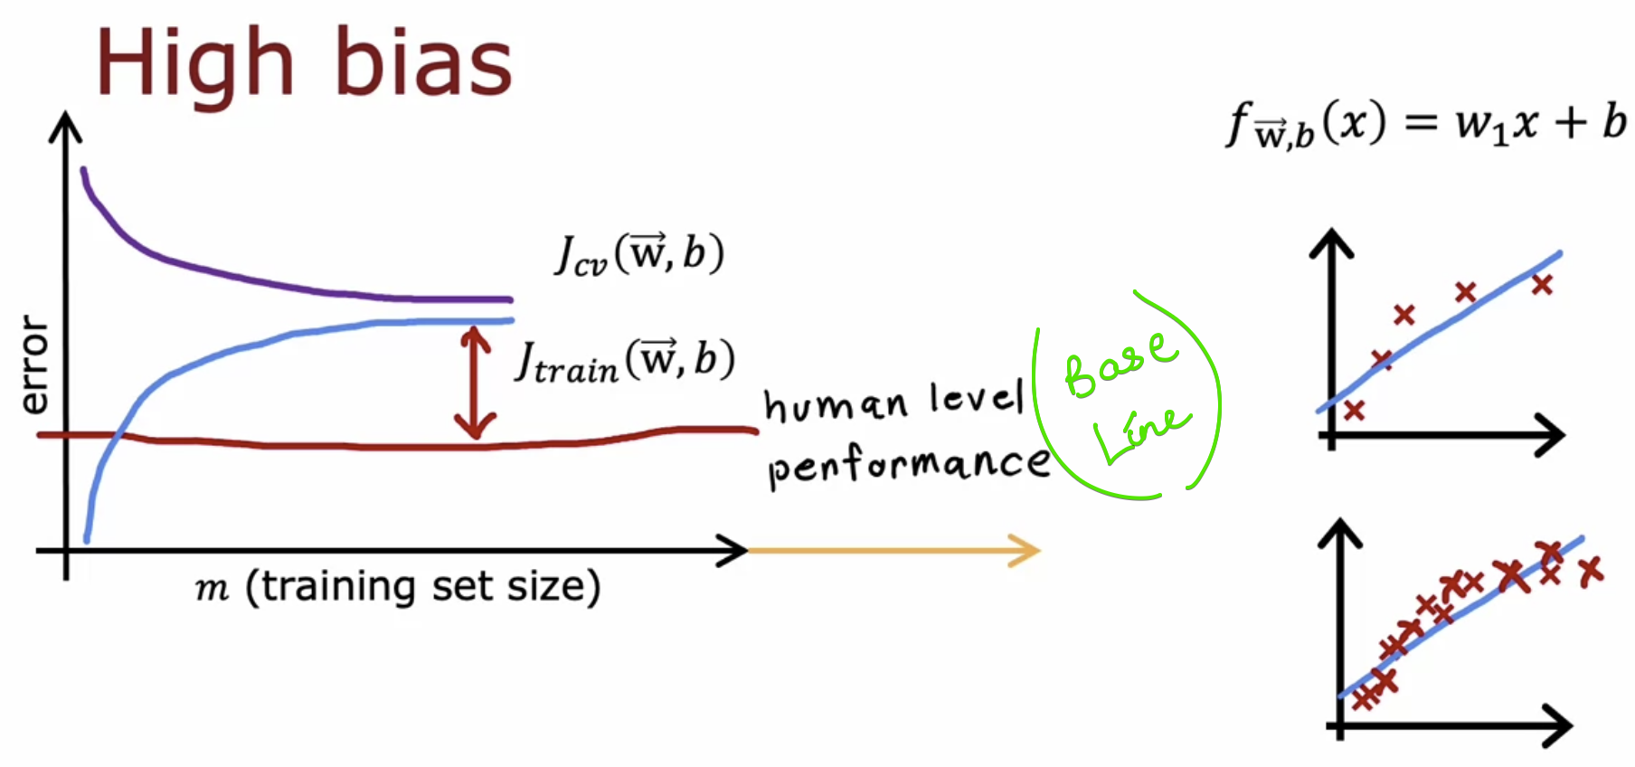

What if, the training data size increases ????

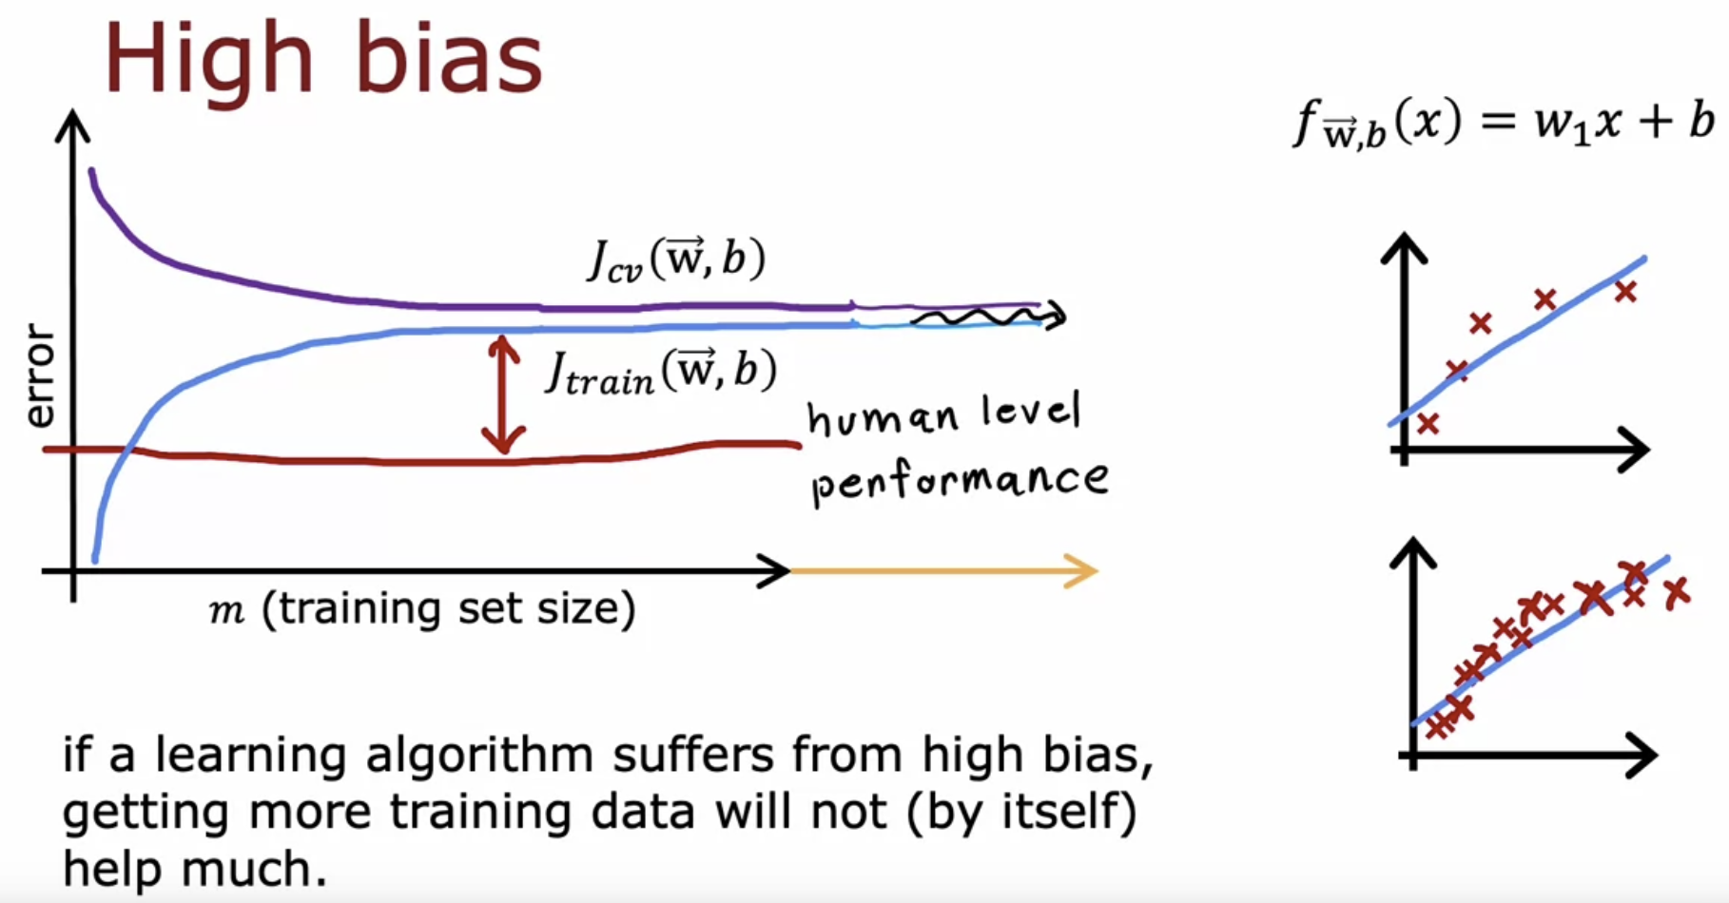

High Bias Problem 🡪 Will not be solved by increasing our training data-set size

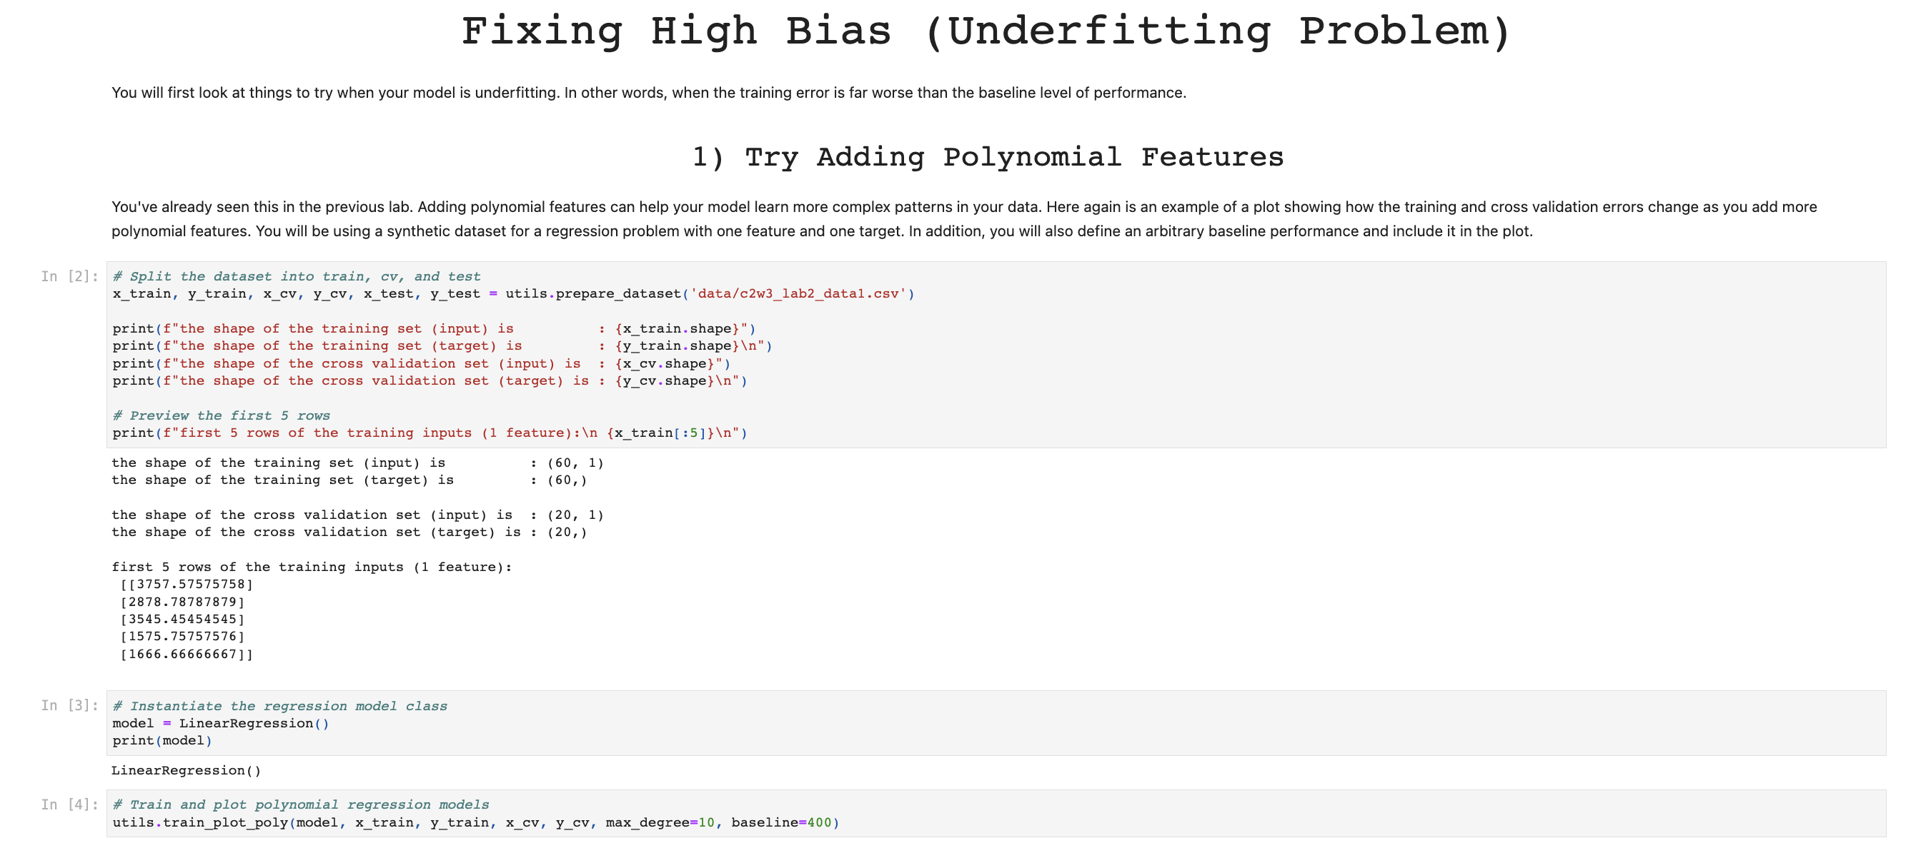

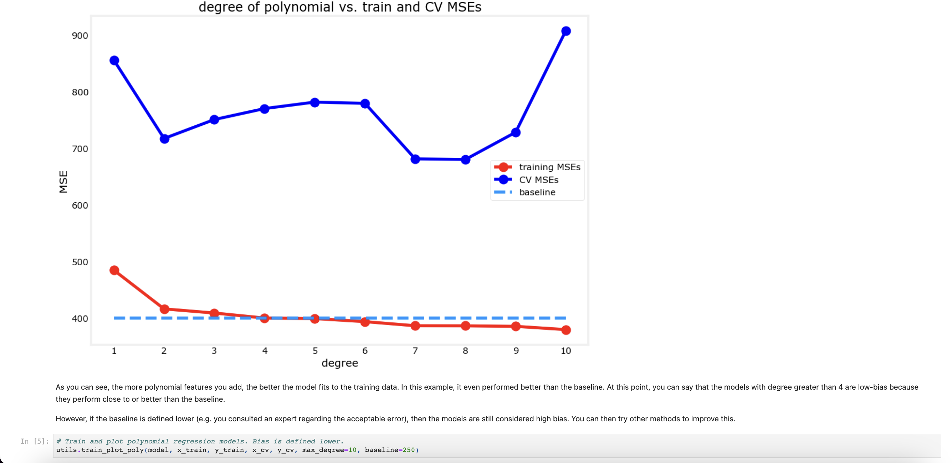

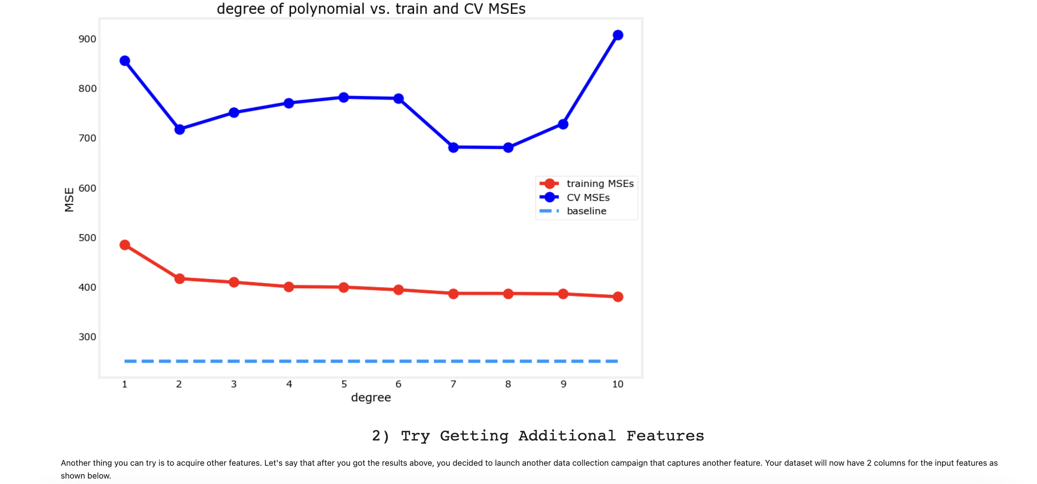

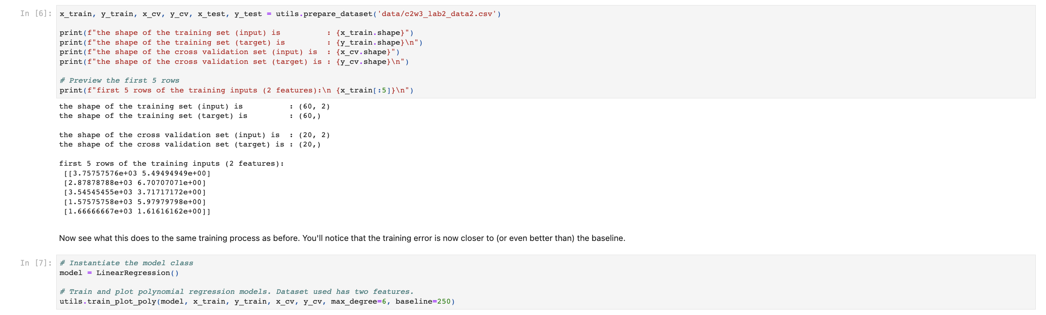

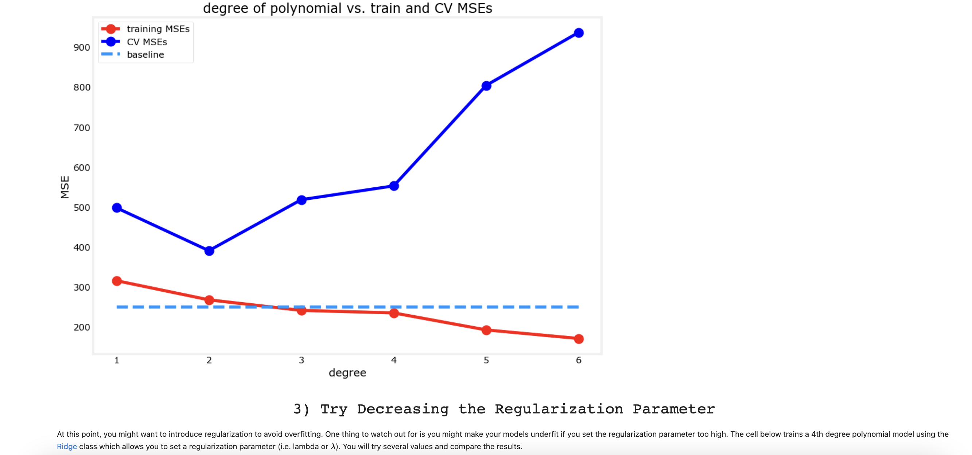

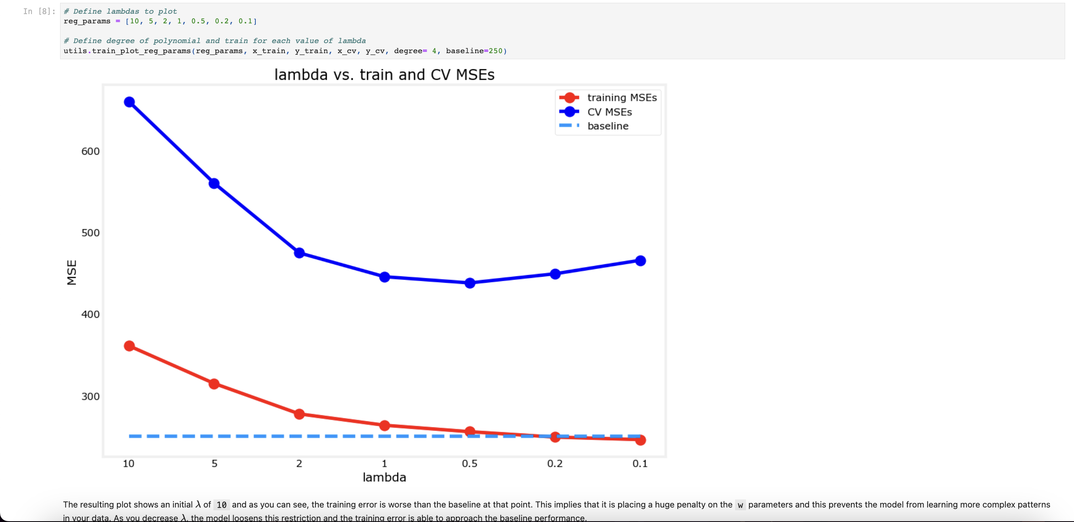

## **High Variance Problem 🡪 Overfitting Problem**

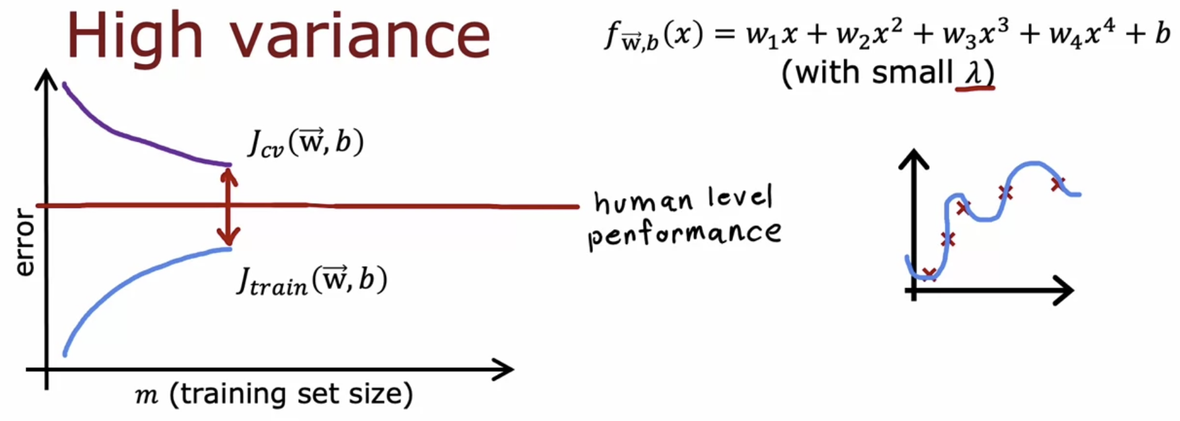  
What if, the training data size increases ????

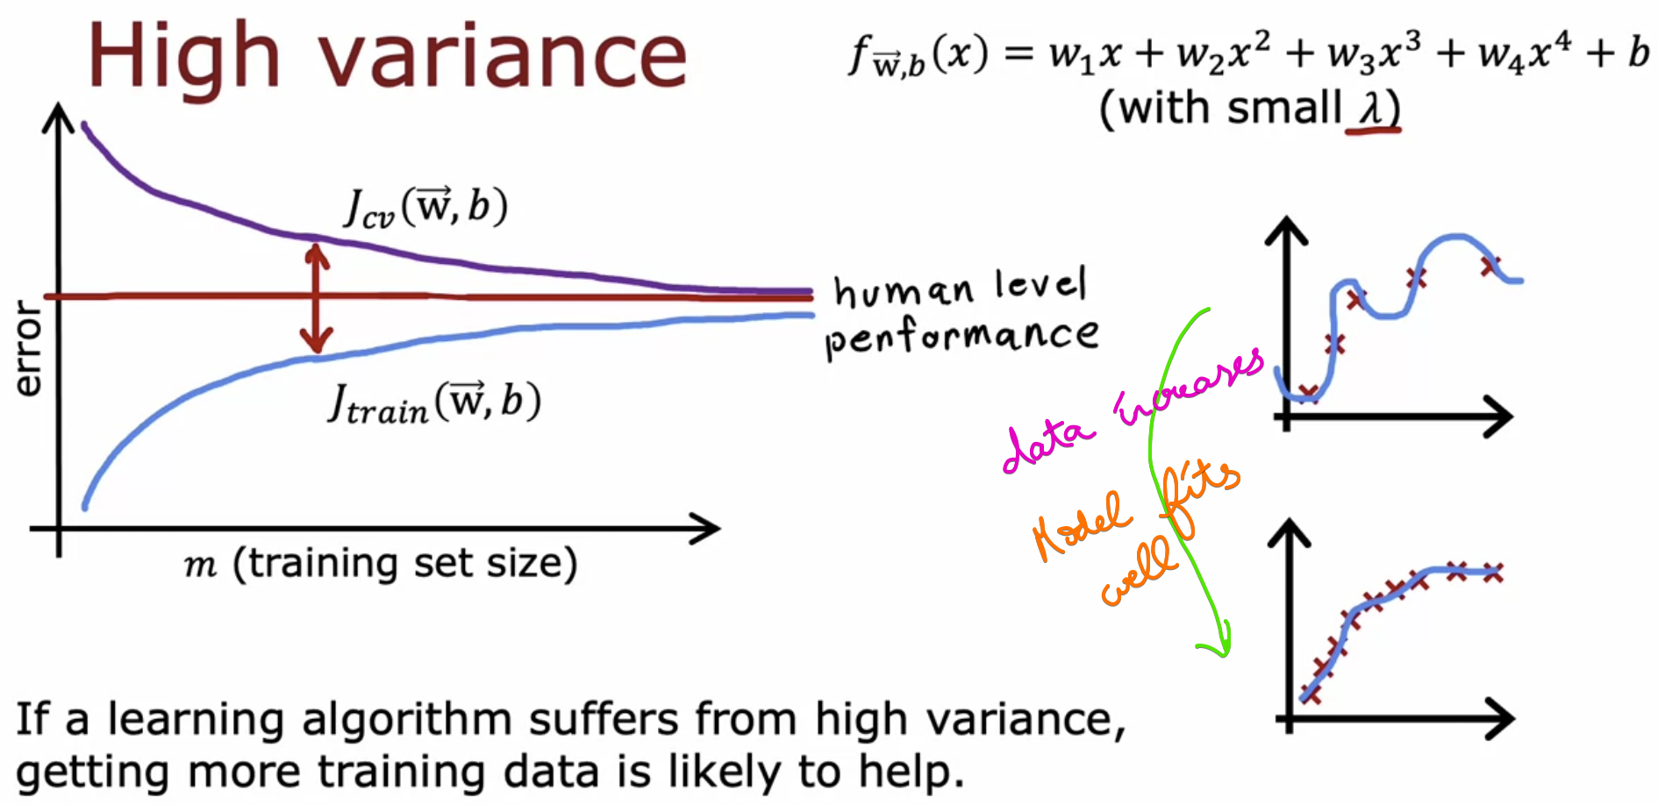

High Variance Problem 🡪 Will be solved by increasing our training data-set size

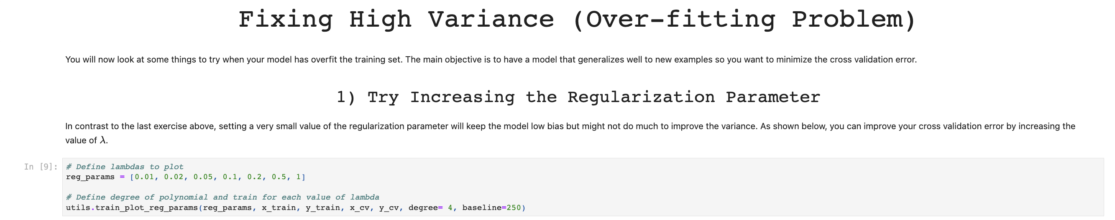  
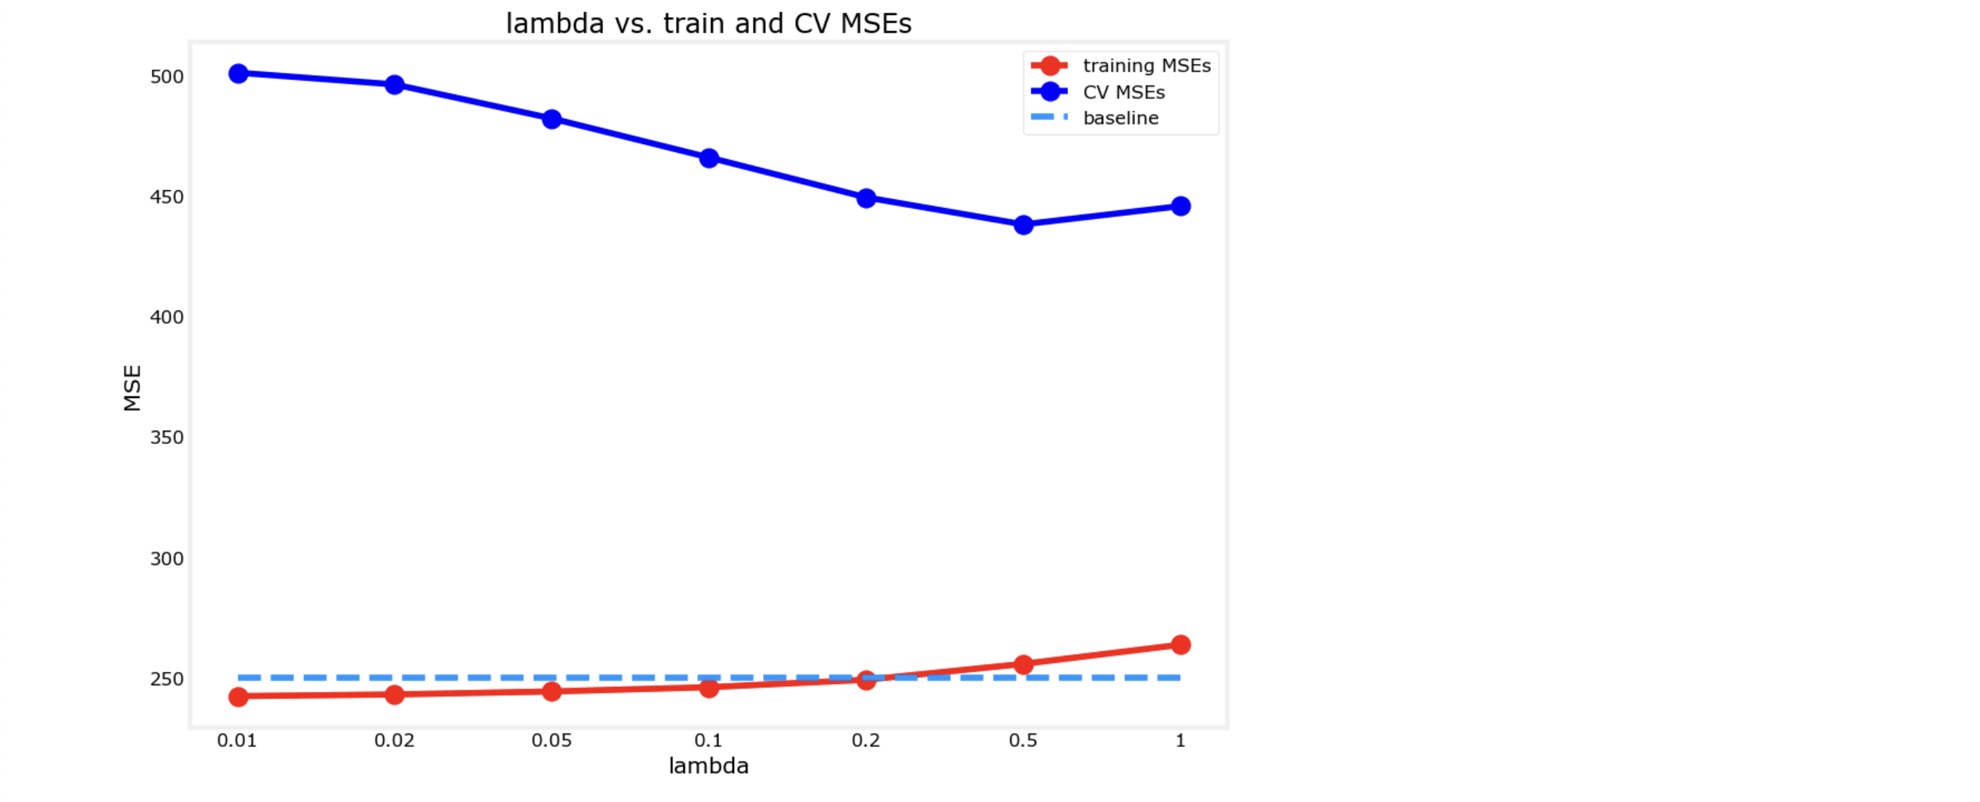

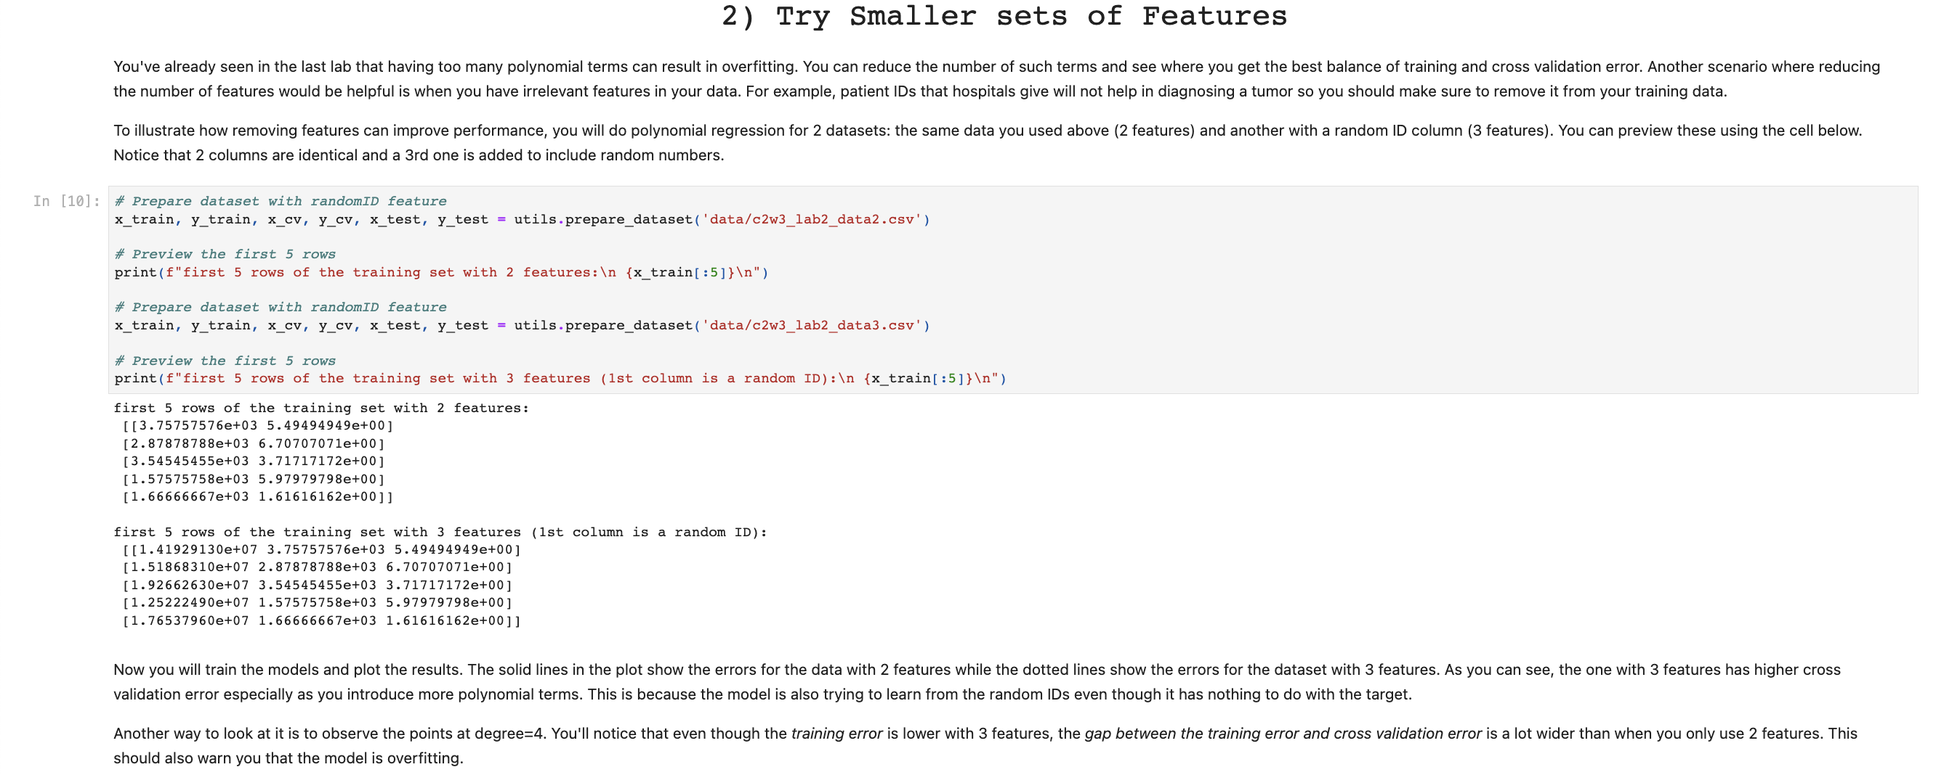  
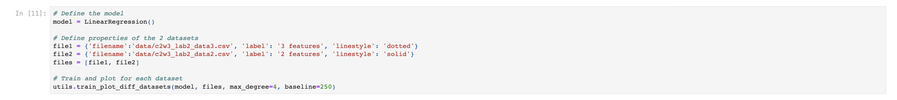

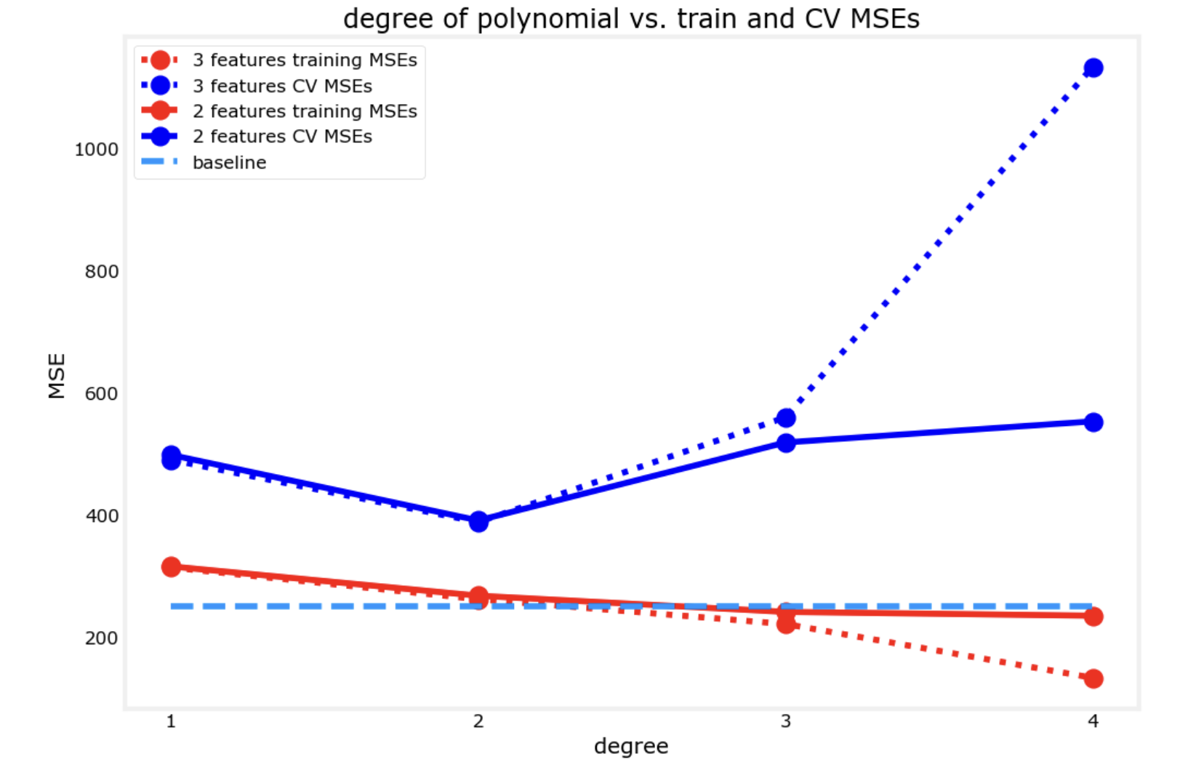

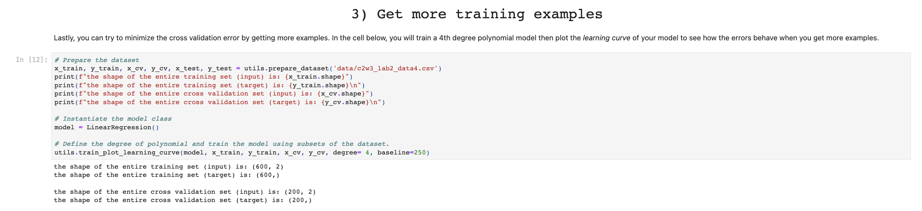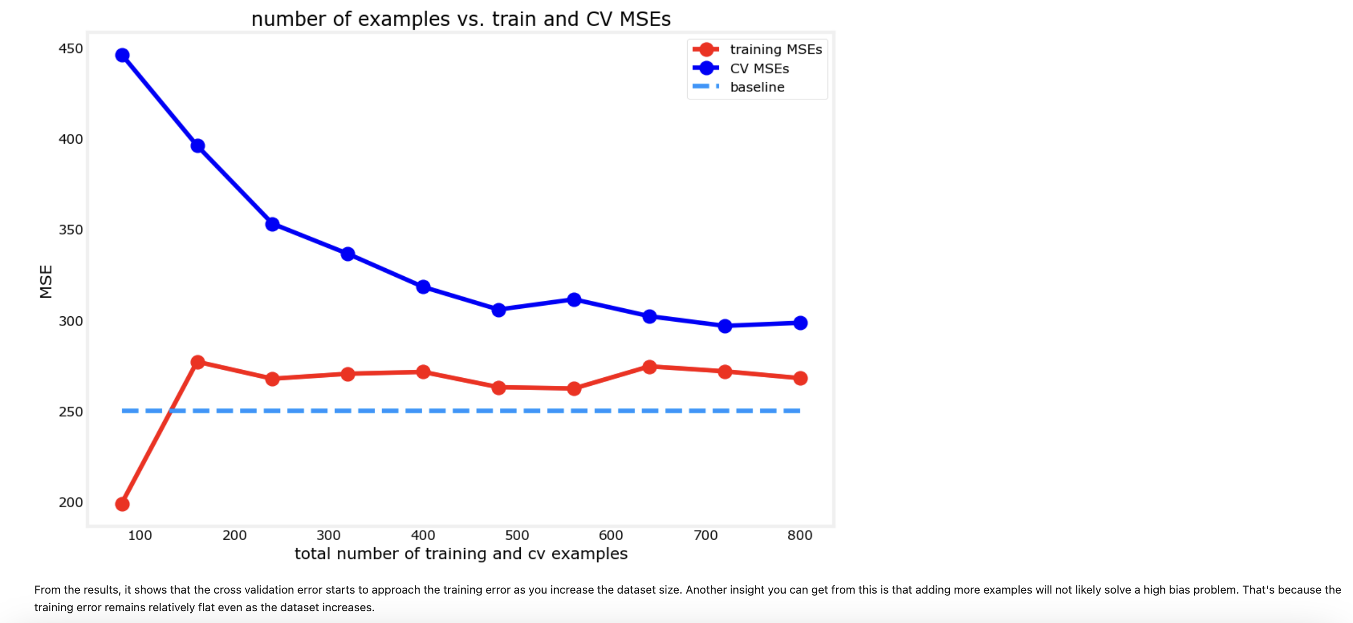

# **Deciding what to try next revisited**

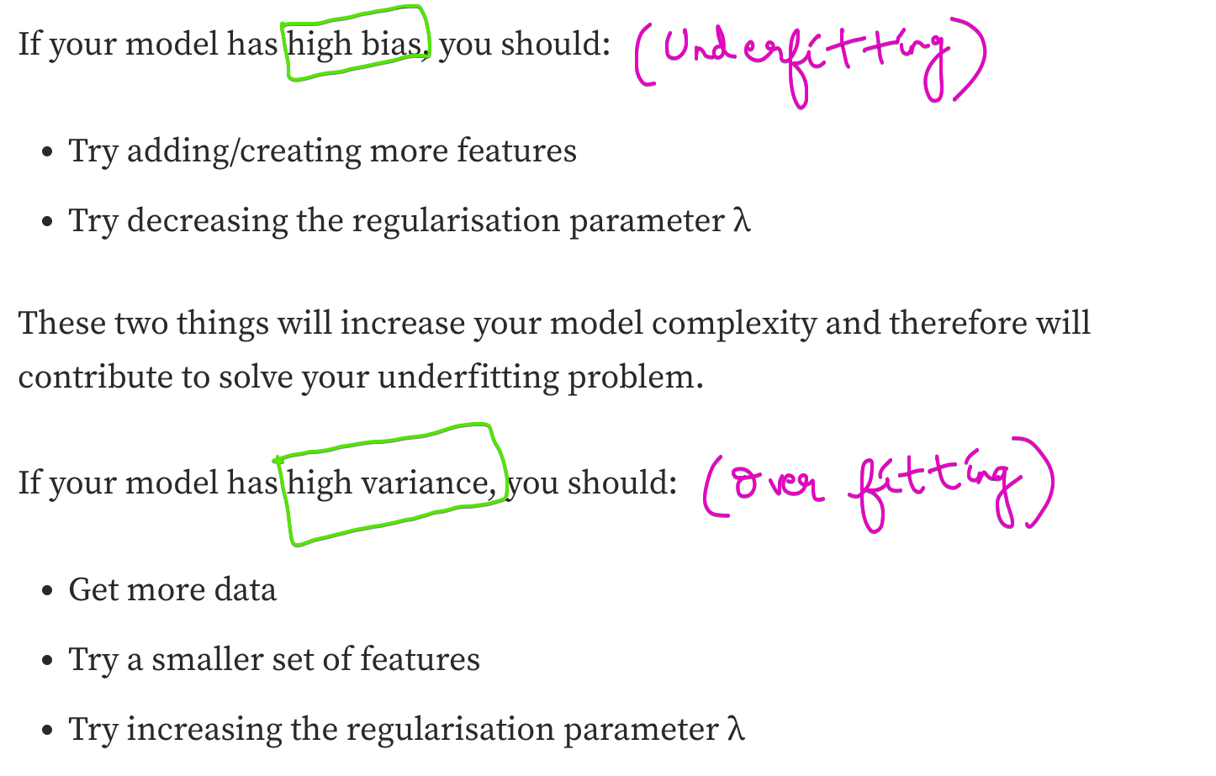

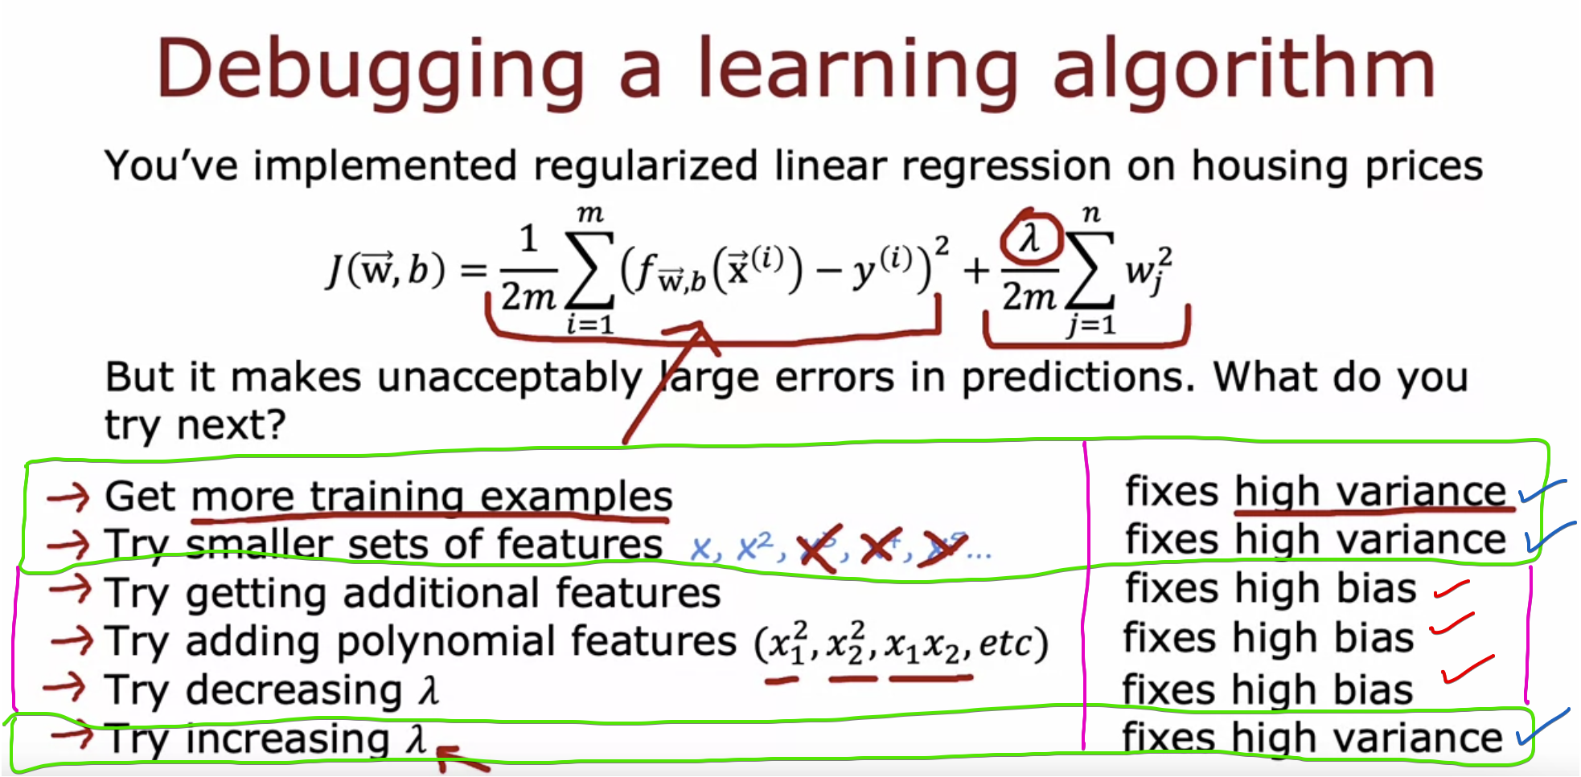

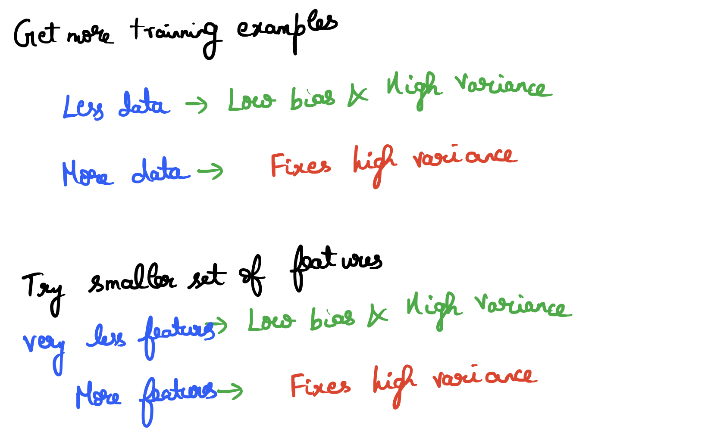

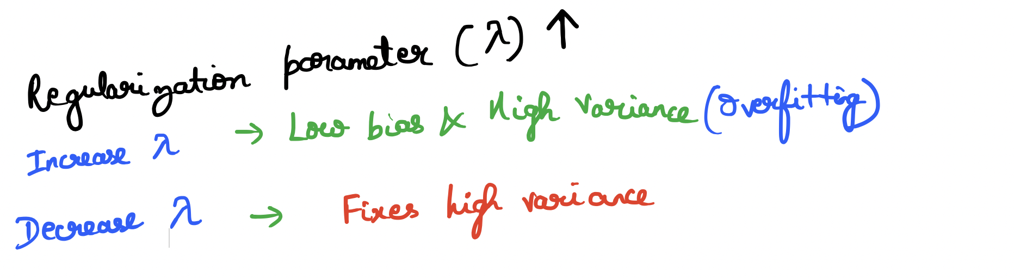

# **Bias/Variance and neural networks**

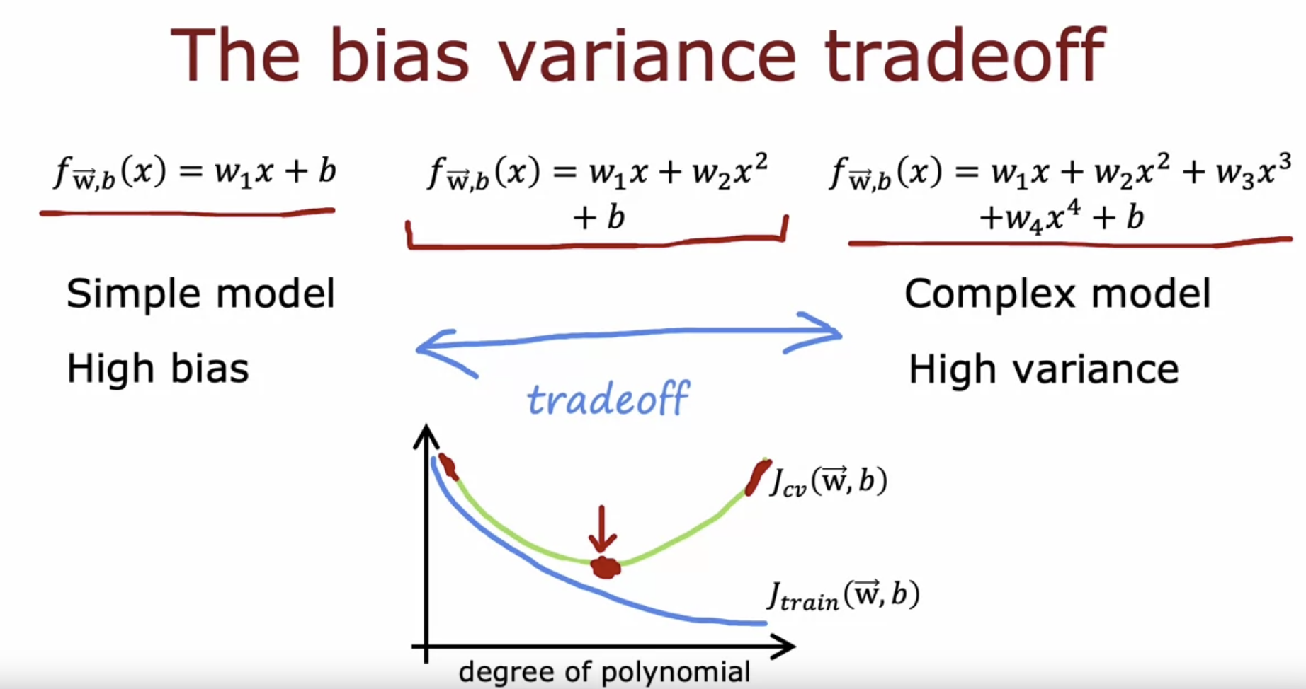

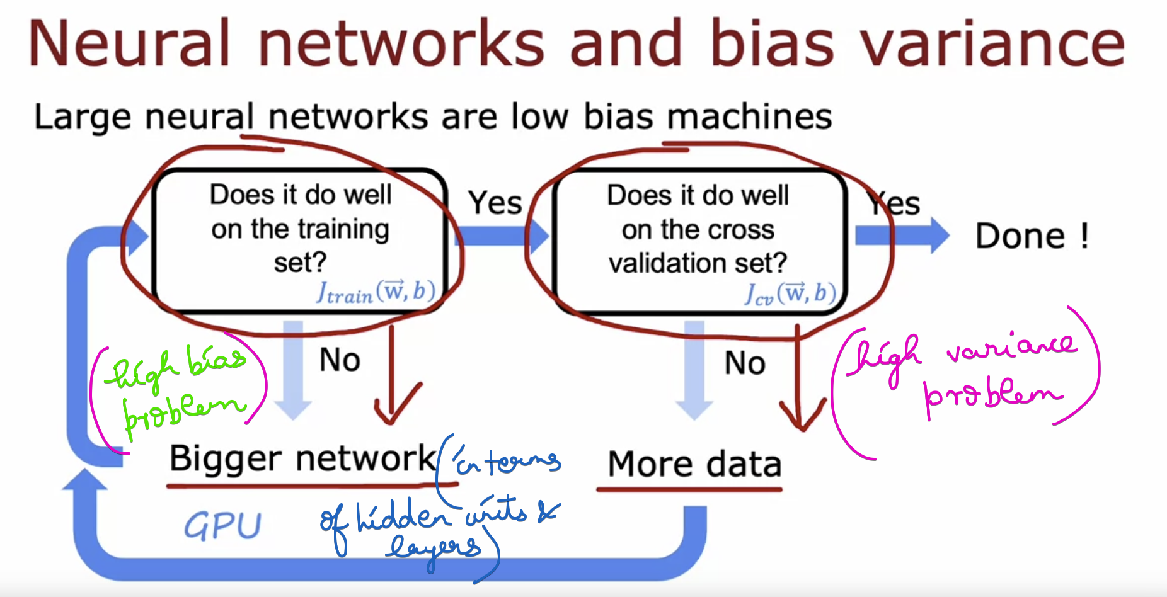

Will my larger neural network creates high variance problem ???

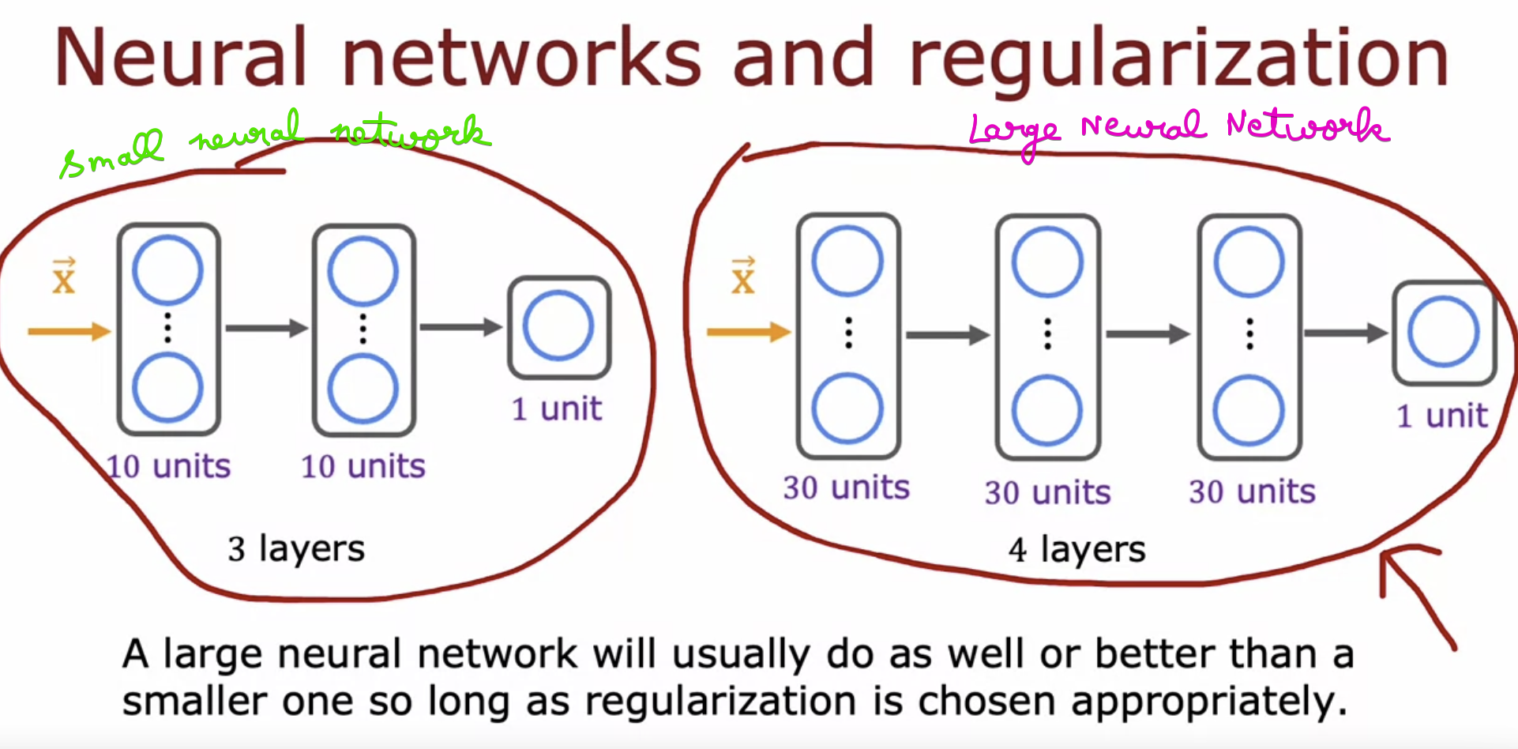

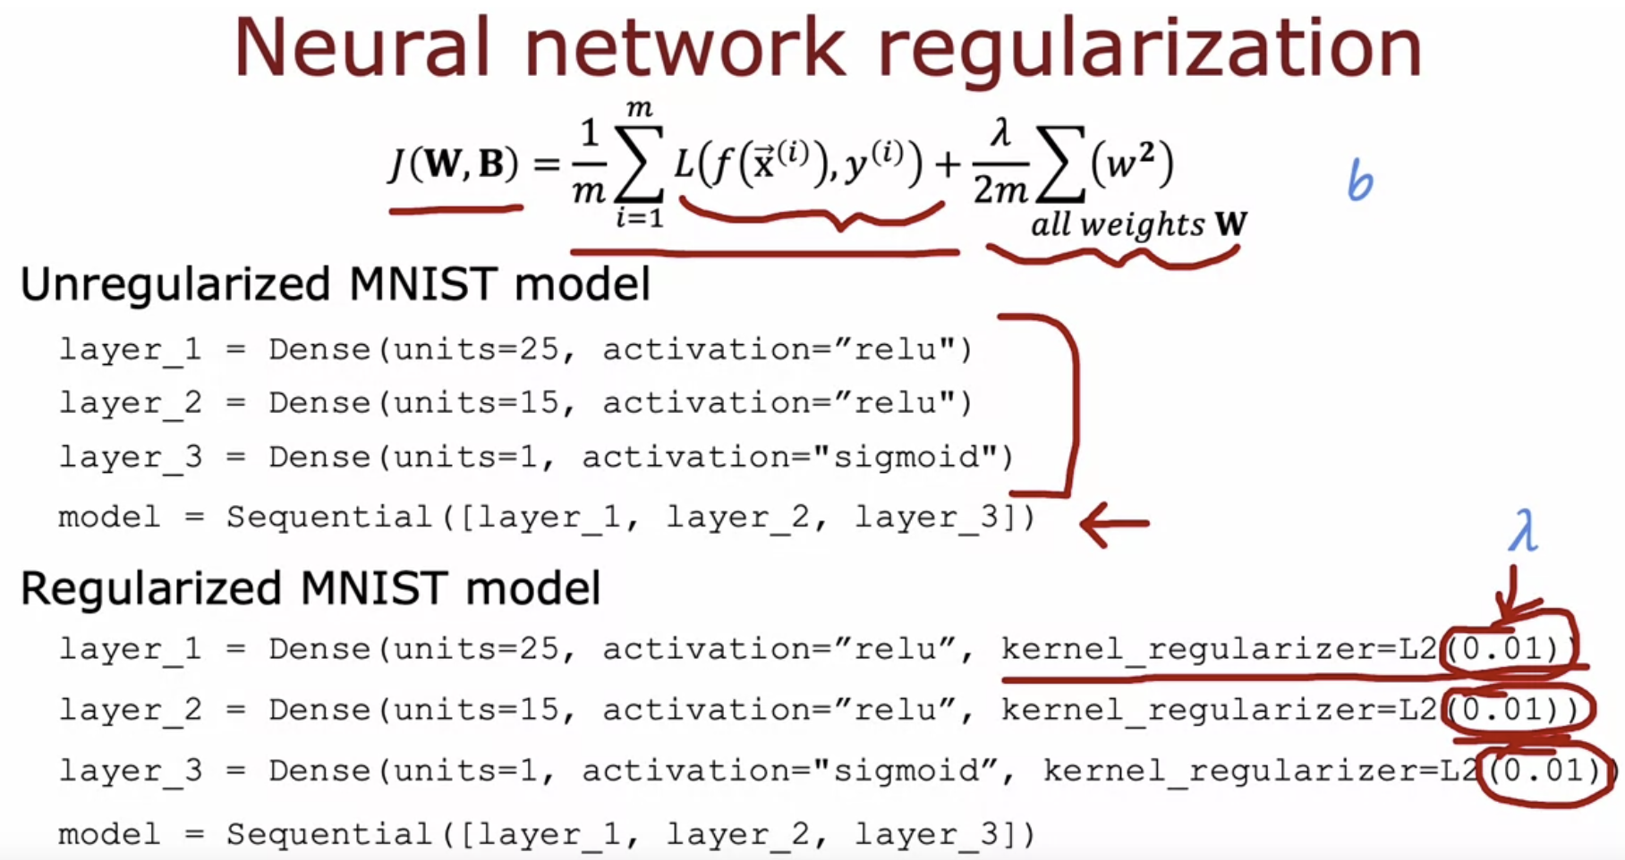

# **Refer Diagnosing_Bias_and_Variance.ipynb**

# **Quiz**

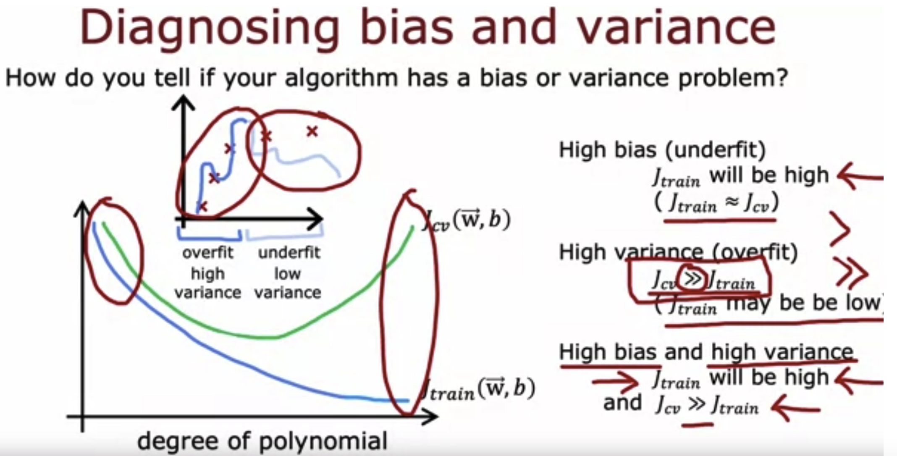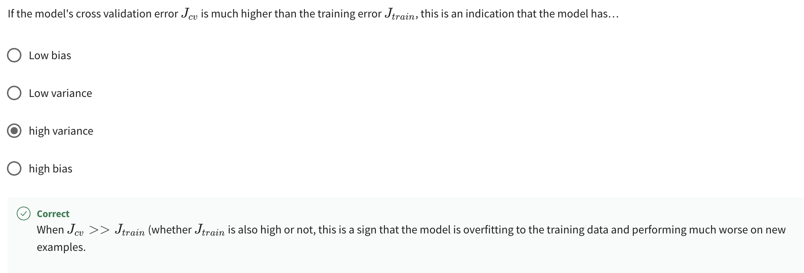

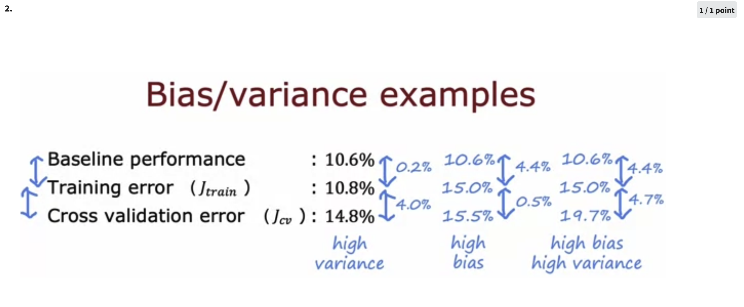  
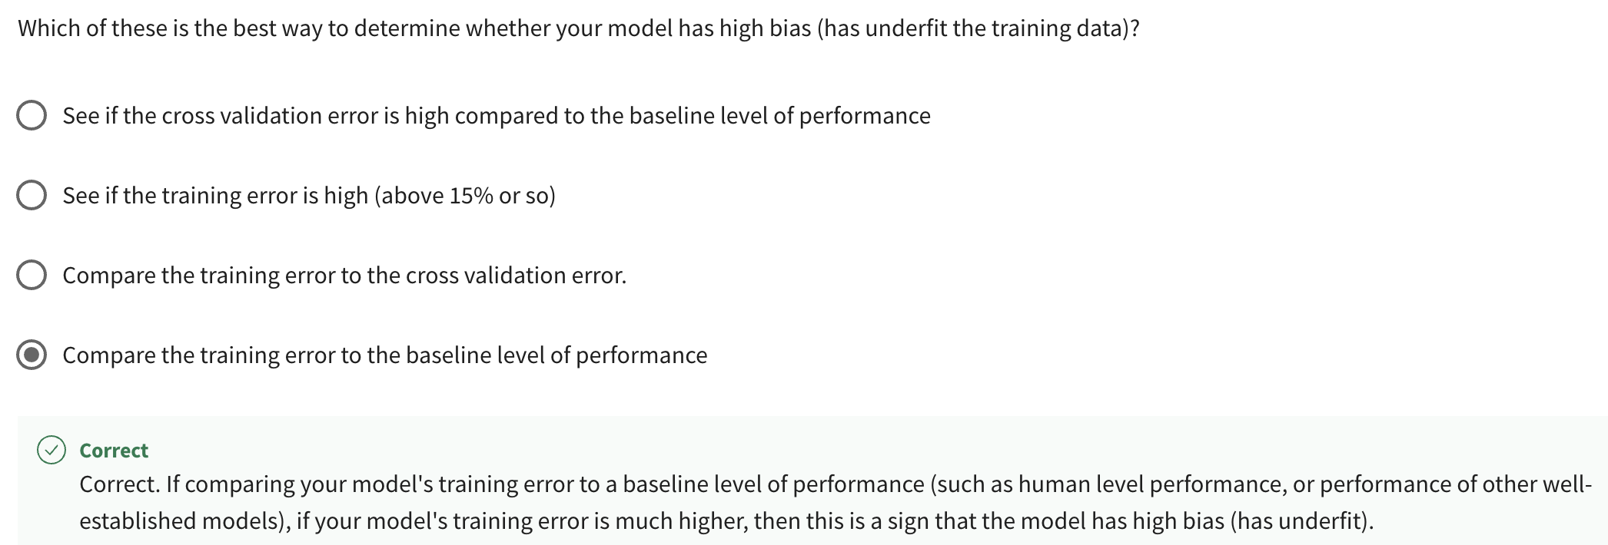

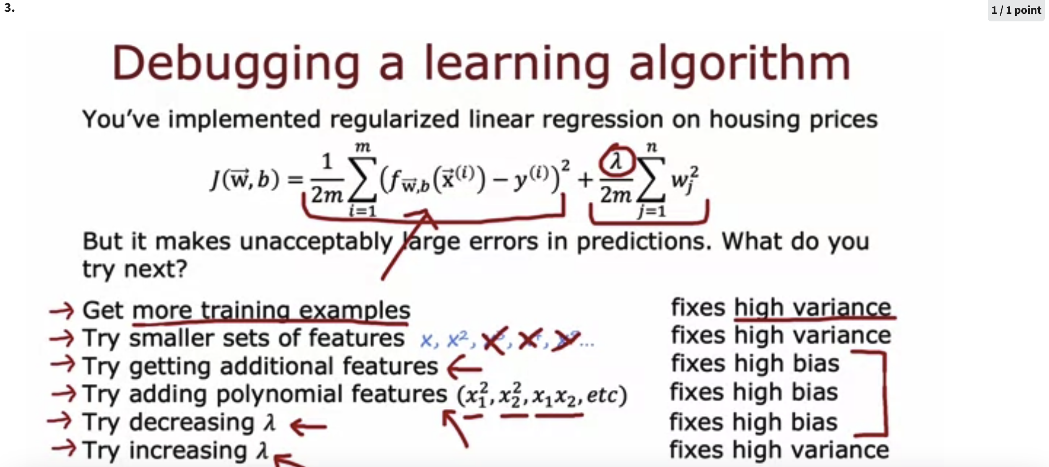

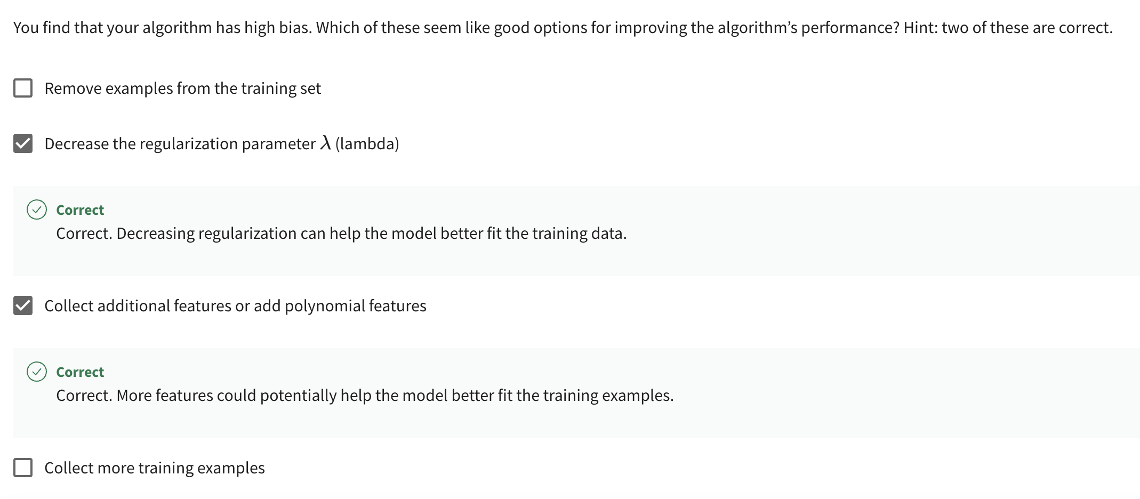

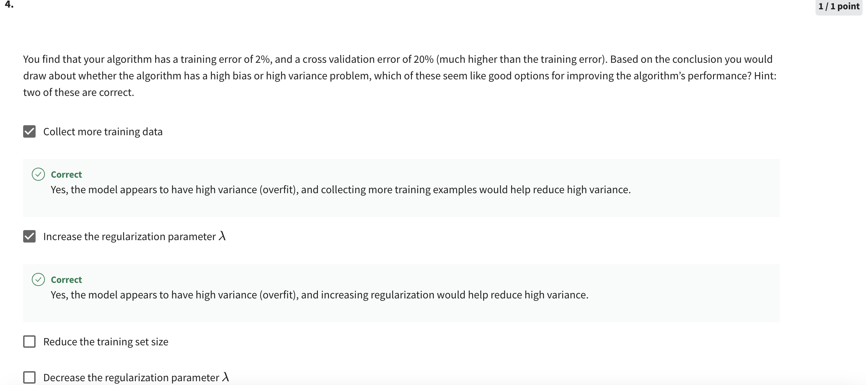

# **References**

[regression - What does "baseline" mean in the context of machine learning? - Data Science Stack Exchange](https://datascience.stackexchange.com/questions/30912/what-does-baseline-mean-in-the-context-of-machine-learning)

[What does 'baseline' mean in machine learning? - Quora](https://www.quora.com/What-does-baseline-mean-in-machine-learning)

[Why you should be plotting learning curves in your next machine learning project | by Adrià Luz | Towards Data Science](https://towardsdatascience.com/why-you-should-be-plotting-learning-curves-in-your-next-machine-learning-project-221bae60c53#:~:text=Learning%20curves%20show%20the%20relationship,suffering%20from%20bias%20or%20variance.)